Davian Peterson

HWRS 482

1/26/21

Challenge 2

Question 1

As head drops directly from 15 to 10 meters, flux remains constant throughout the medium and holds a steady state condition.

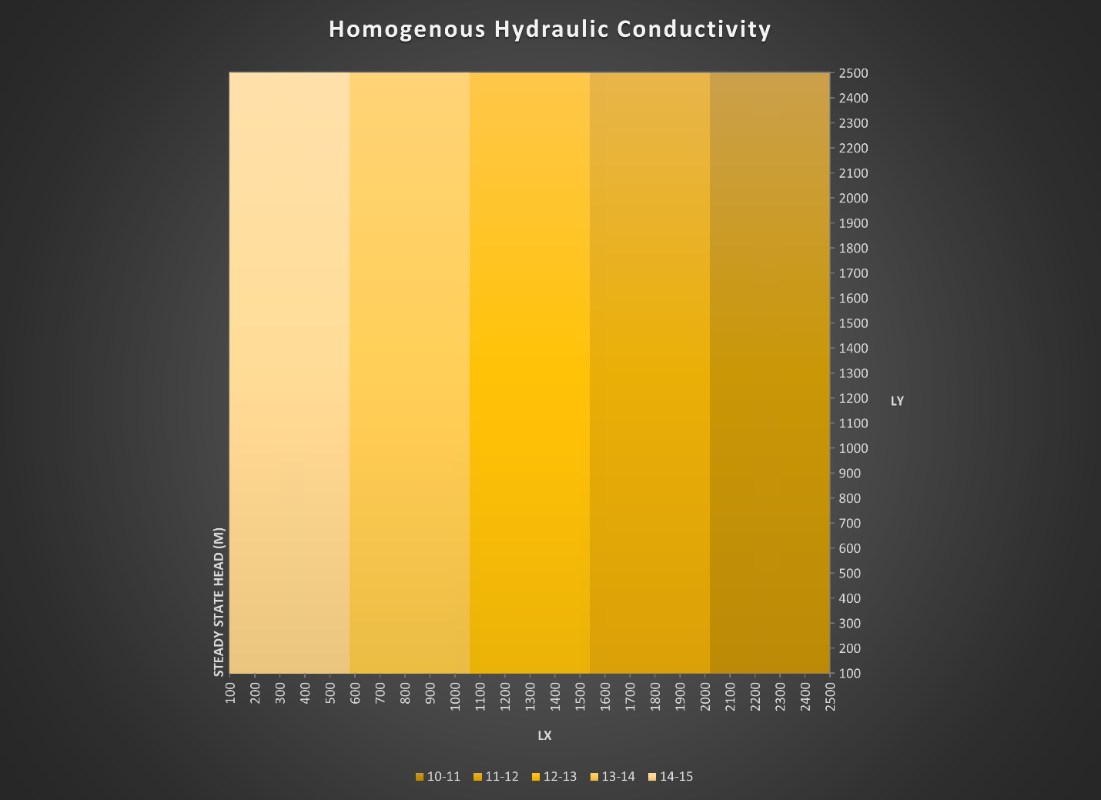

Figure 1: characterization of head through a medium of homogenous hydraulic conductivity

Question 2

While head changes at different rates horizontally, deltaH is equal between high and low Y. Keq can be modeled using a harmonic mean which produces an output that favors lower inputs.

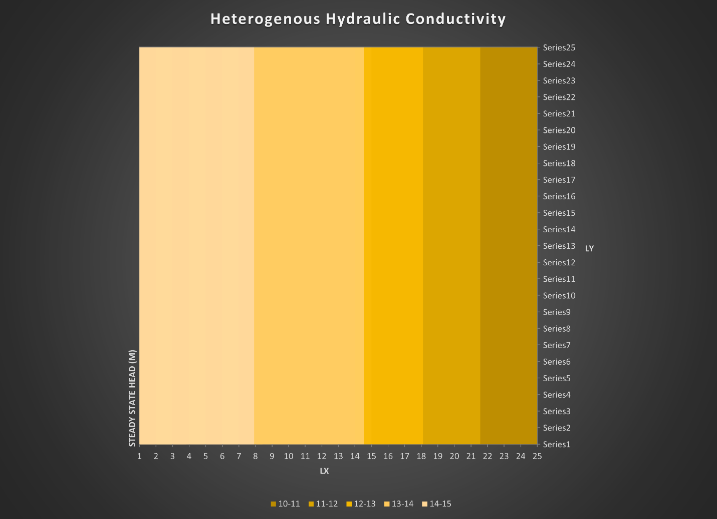

Figure 2: characterization of head through a medium of heterogenous hydraulic conductivity

Question 3

It appears that areas of lower hydraulic conductivity draw the contours in. Despite the greater K occupying a greater area, Keq is likely restricted by the lower K. In this model, you have distinctions between Ks that exist parallel and perpendicular to flow and not a very intuitive way to balance the two methods for deciding how Keq is impacted.

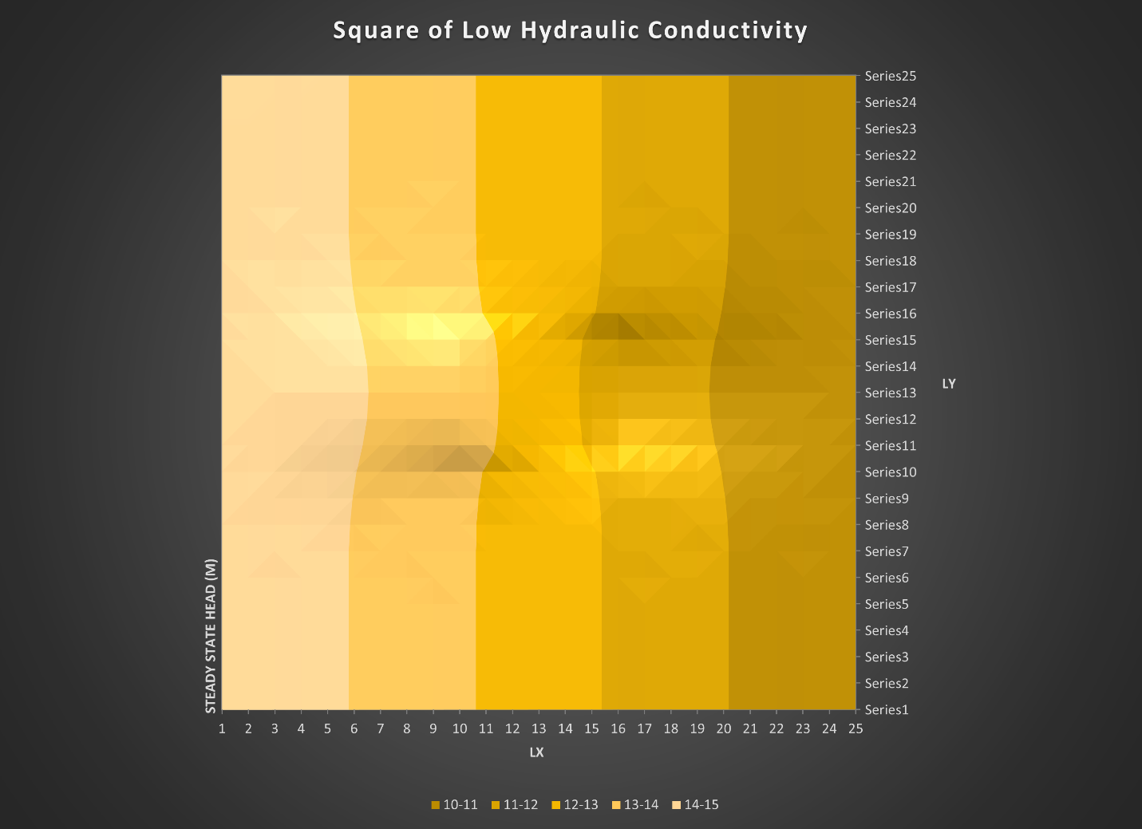

Figure 3: characterization of head through a medium where the center is less conductive